That WA Public K12 has failed is no longer a question. The question is “can it be fixed.”
Despite teacher salaries as high as $170,000.00 / 180-day work year and administrator salaries that begin there, WA K12 has an over 70% FAILURE rate in getting students minimally proficient. Can it be fixed?
My belief when I approached several schools to try and do volunteer Math tutoring was that it needed to be. What I learned having “gotten in” makes me question whether it can. Here’s what I encountered in practice and in researching data and policies:
We have an unaccountable system:
Students are promoted from grade to grade (rewarded) despite failing to meet minimum proficiencies for the next grade. This is resulting in a some 40-60% of students arriving in HS 3 to 6 YEARS behind. Another way to look at this is… there is a lack of quality control.
Teachers are rewarded for longevity and the classes they take and pass and not on what they produce. Consequently, we have teachers making $170,000 /180-day work year with a less than 10% success rate in getting students minimally proficient.
DEI needs to DIE!
DEI has permeated virtually every corner of Washington State Public K12: from the university degree programs to the school improvement (WSIF) and teacher evaluation frameworks (Marzano) to the school districts and classrooms.
There are two significant issues with this approach:
- It obfuscates the problem:

- It presumes a solution based
https://sbe.wa.gov/about-board/mission-and-vision/equity#:~:text=Educational%20Equity%20and%20Inclusion%20Statement,-The%20Washington%20State&text=The%20Board%20is%20committed%20to,the%20needs%20of%20every%20student.

Some of it is laughably ironic:
- A high-income area school’s webpage with copious DEI policies conspicuously and prominently displayed… and a minority student population so small it’s performance can’t be published on the Report Card…even if you aggregated ALL of them together… well… except for Asians who evidently don’t count as a minority.

froFrom the requisite certification and degree programs for K12 Teachers and Administrators offered by Higher Ed to the mission and vision statements of virtually all of Public K12 to the frameworks designed to manage and improve Public K12 such as “SMARTIE” (“SMART” being a well-respected project management framework “Improved” to include the “EI” of “DEI”) and frameworks designed to evaluate Teacher Performance such as Marzano.
The problem: Exactly what is DEI… and how do you objectively measure it so that we can assess its impact on student performance? Or, do we need to?
At a high level, per Sup. Reykdal, DEI is a “core component of Washington’s (K12) Educational system.” But it was introduced into WA Public K12 about 30 years ago and by every objective measure, student performance is still tanking. This would suggest that maybe we’re on the wrong horse.
Are there possibly factors beneath DEI’s Gender/Race/Eth numbers that might be more indicative of a core issue or problem? As it turns out… yes: Students of Low-Income families tend to under-perform… no matter what their race.

There does appear to be a moderately strong to strong positive correlation between a school’s performance for low-income students and its performance for individual racial groups: r = .63 for Asian; .71 for Black; .75 White; and .81 for Hispanic students. The trend agrees with other published research and opinions.

Public data does not disaggregate for Percent of (e.g.) white students in poverty that met standards so we can’t really evaluate how poverty specifically affects racial performance.
Based on the (redacted) Report Card Data… the correlation coefficients range from roughly: .63 for Asian; .71 for Black; .75 White; and .81 for Hispanic students. The trend agrees with other published research and opinions.
Where things fall down is when we go from “poverty” to “poverty and communities of color” in an attempt to make this about Race/DEI.

Consequently, we can only test whether a group of students do better in schools with a low percentage of students from low-income households.

so we can’t test whether it’s Poverty or Race that is the core issue.

is captured as it’s own metric (publicly) so we can’t test whether members of a group perform better pending their co-membership in a poverty household.

on can’t say whether a group performs better

are two problems with this approach: 1) How do you measure DEI… OBJECTIVELY!
Yes, Black and Hispanic students overwhelmingly under-perform compared to Asians and Whites on the Standardized Tests. BUT, if racism is the issue … then why do Asians out-perform Whites? The US has been at war with Asian countries since the WW II!
One possible explanation offered by Black Leaders is the disparity in divorce rates and, consequently, (predominately) single mother households: The Black community’s divorce rate is 3 times that of the Asian community. Unfortunately, OSPI doesn’t capture that metric.
Another is Poverty. In comparing Correlation Coefficients, one of the strongest I’ve found is between the percent of low income students to those meeting standard
killed over 2,000 at Pearl Harbor, 100,000 US soldiers in Asia in WWII, 36,000 soldiers in Korea and 58,000 in Vietnam. Seems like we’d have a pretty strong argument to be racist against Asians… IF we were in fact a racist society. And yes, I am deliberately co-mingling the Asian races… just like we do on Report Card.

Could there be a social phenomenon associated with the races that better explains the disparity in performance?
Turns out Poverty might be that

. Available data is not conclusive… but it appears that Poverty may be a bigger driver in poor performance than DEI issues.

a causation to the problemperformance.services.

SMART, a proven PROJECT MANAGEMENT framework (Not a Program Framework) used in the private sector to set effective goals and milestones has been brought in and renamed “SMARTIE” (editorial comment omitted) to include an Equity and Inclusion dimension … because “it’s crucial to consider how [educational goals] will impact different groups and ensure fairness and justice.”
The Marzano framework which appears to be used by our local ESD to evaluate teachers is heavily DEI influenced and proposes, amongst other things, that teachers prepare and tailor lessons to (their estimated 120) individual students.
As a coach, I found it easier (and more productive) to unite players around an objective such as winning a soccer game than focusing on their individual differences.

Poverty (and divorce) are problems!
Looking at the 2023-24 data, with only 1 or 2 exceptions (Choice Academy – 25 students 14% met 42% low income), the only schools with greater than 50% of students meeting a minimum level of proficiency were those where over 50% of the students came from NON-low-income households.
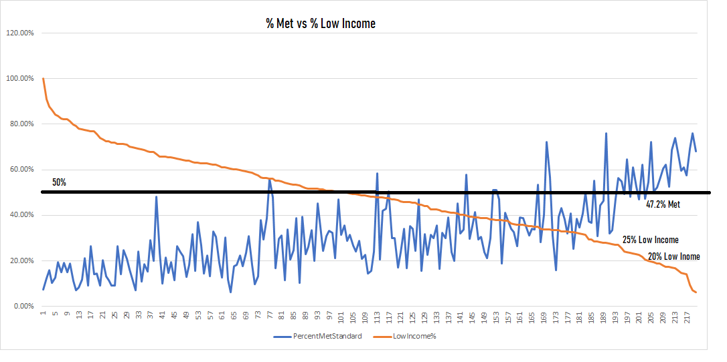
If we look at racial differences, Asians are the highest performing (60% met) with Black/Hispanic the lowest (12% met). Asians also have the lowest divorce rate… roughly a third of Hispanic and Black/African American. IF, as the data suggests, divorce and subsequent father absence is a factor then the solution is going to lie in Family Law reform… a concept some black leaders have been championing for over a decade.
DEI needs to DIE!
DEI has permeated virtually every corner of Washington State Public K12: From the requisite certification and degree programs offered by Higher Ed to the mission and vision statements of virtually all of Public K12.
SMART, a proven PROJECT MANAGEMENT framework used in the private sector to set effective goals and milestones has been renamed to “SMARTIE” to include an “Equity and Inclusion” dimension and adopted by WA Public K12… because “it’s crucial to consider how [goals] will impact different groups and ensure fairness and justice.”
The Marzano framework which appears to be used by our local ESD is heavily DEI influenced.
None of this explains the low performance where these “marginalized groups” are the vast majority of students.

https://summitps.org/our-schools/summit-atlas-west-seattle/

to evaluate teachers

Does the data support either the basis for doing this and/or the benefit from doing it?

administrators are required to take to be eligible to serve to the “Program/Project Management” frameworks

Washington’s OSPI/SBE have brought in “frameworks” such as UDL and Marzano which, at their core, are designed around DEI.
These frameworks encourage/mandate/suggest (pic one) teachers create individual lesson plans considering student proficiency level and culture. Think 20 students per class times 6 classes a day = 120 students… with half the students stuck somewhere between the 2nd and 8th grade.

We are also using a “goal setting” framework… which presumes

https://www.edweek.org/teaching-learning/seattle-schools-lead-controversial-push-to-rehumanize-math/2019/10#:~:text=The%20Seattle%20school%20district%20is,power%20in%20a%20math%20classroom.
https://komonews.com/news/local/school-district-teaches-math-is-oppressive-insists-kids-recognize-inequality-of-testing

chrome-extension://efaidnbmnnnibpcajpcglclefindmkaj/https://equitablemath.org/wp-content/uploads/sites/2/2020/11/1_STRIDE1.pdf

